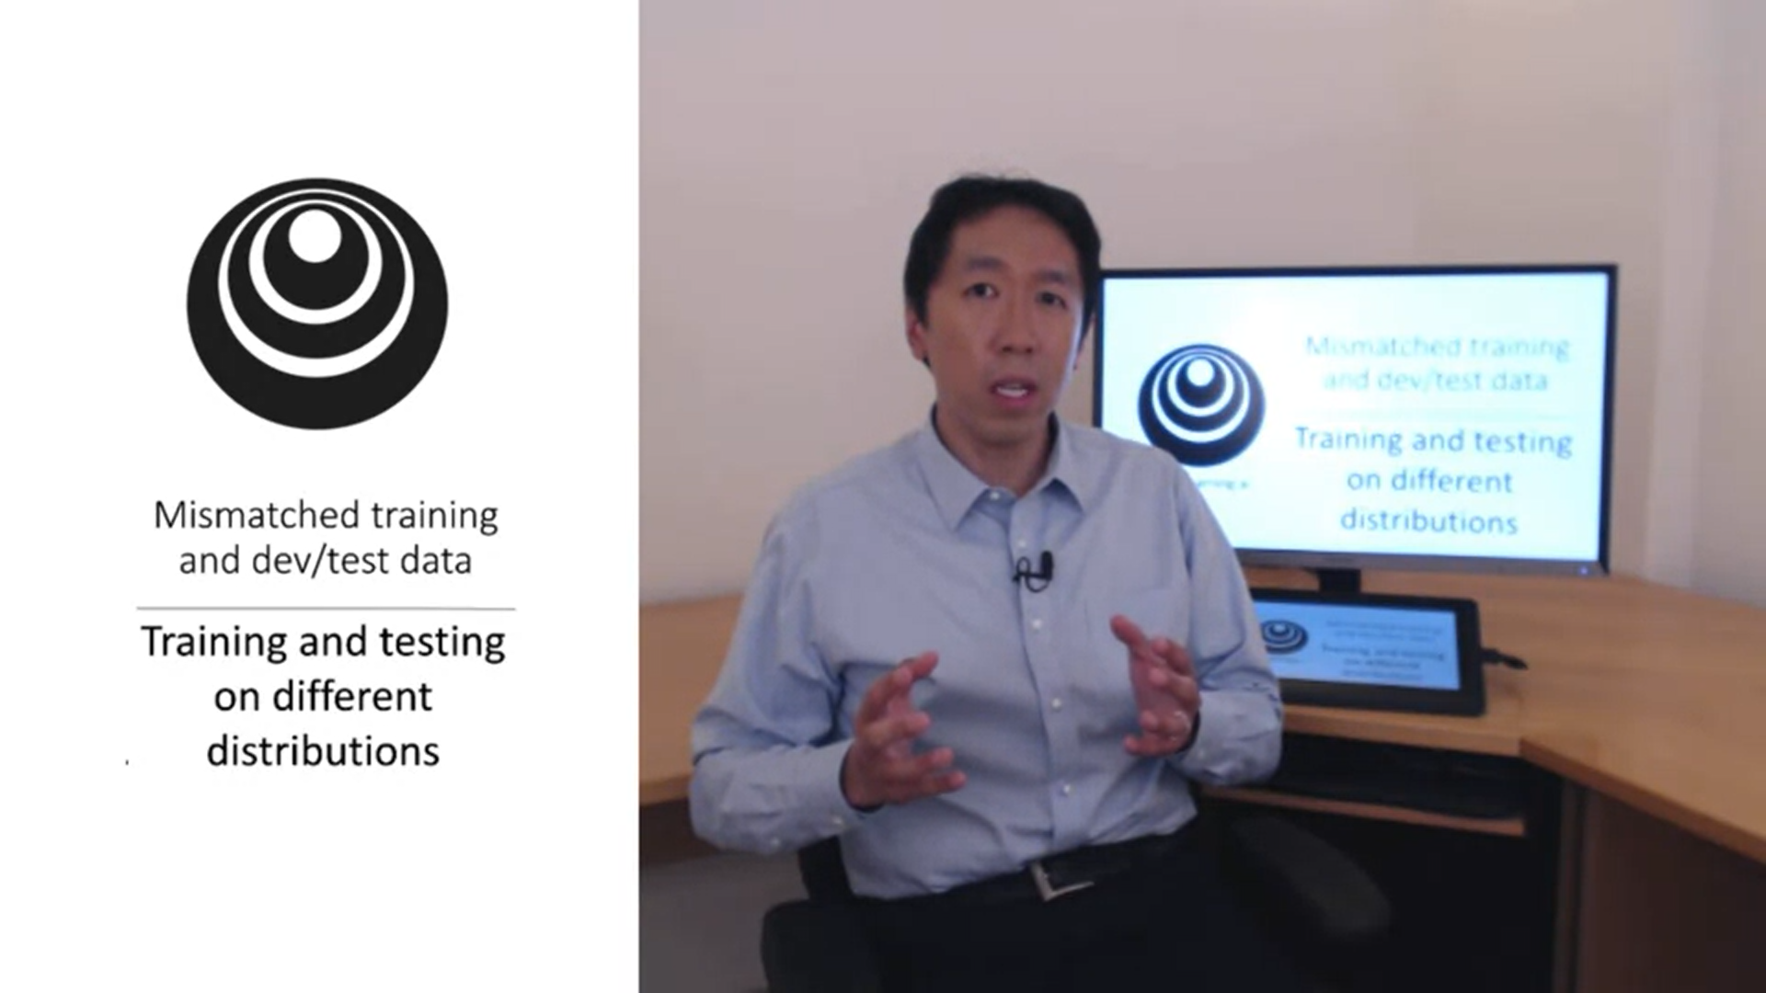

DL algorithms have a huge hunger for training data. A lot of teams thus take data also from other distributions than the dev and test set to train their algorithms. There are some subtleties that are important here.

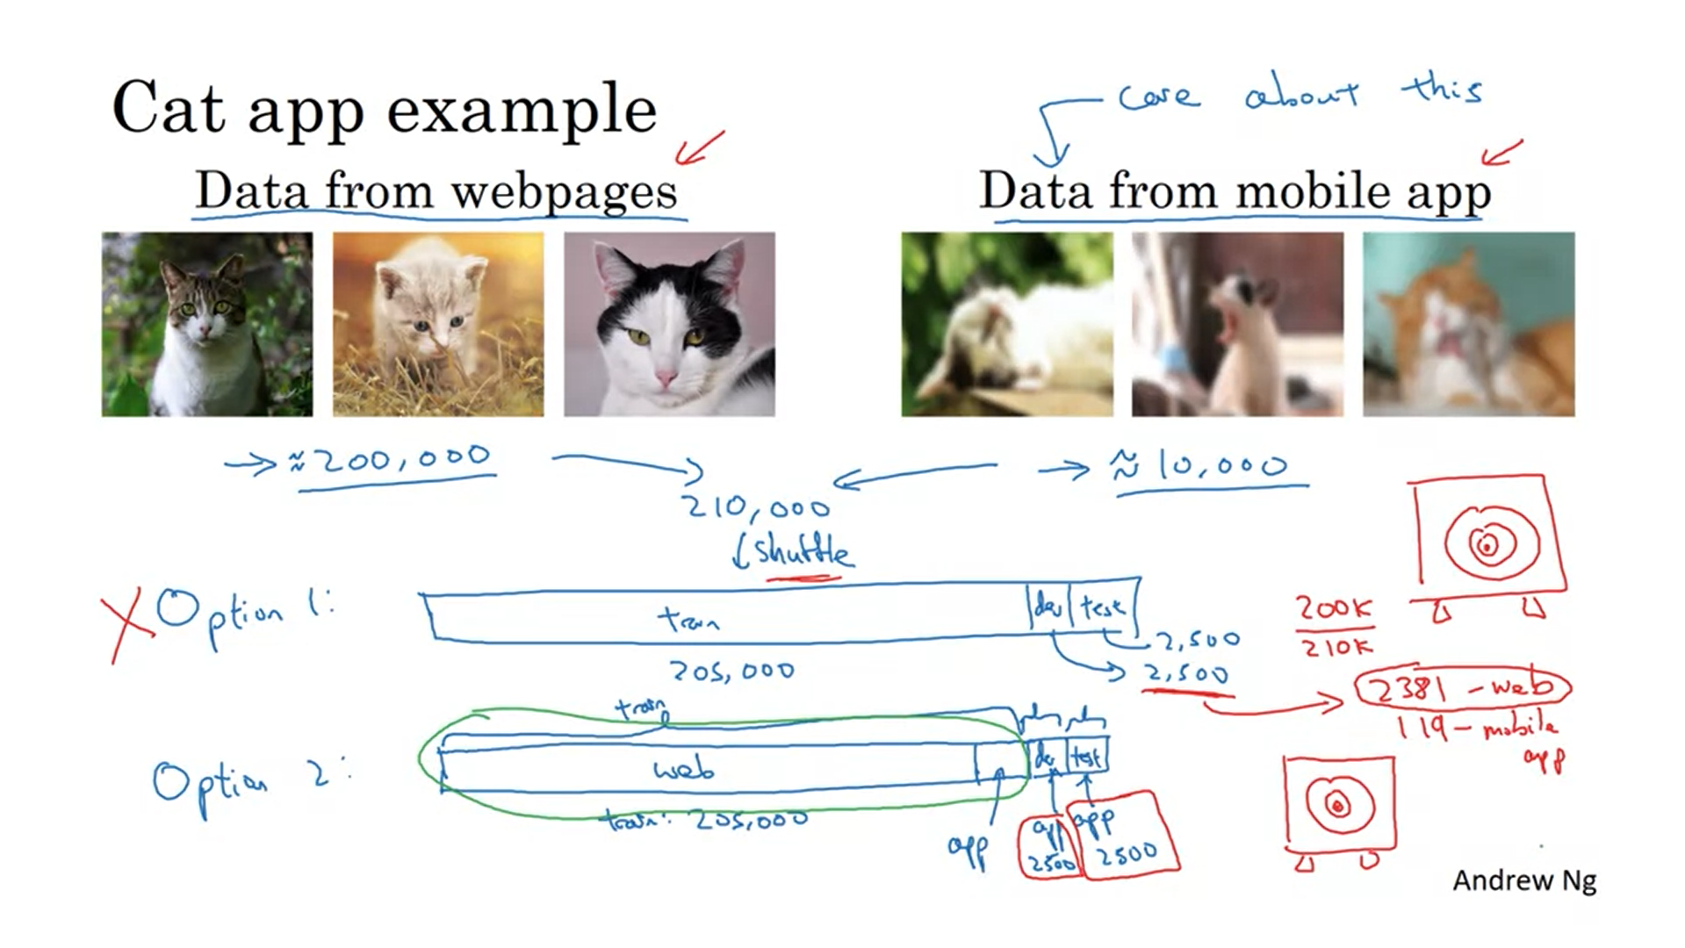

Example: recognize cat in mobile app.

High resolution images from webpages but not so many real images from the app yet.

We are in a bit of a dilemma because we only have little data from the distribution that interests us. What do we do to use this most efficiently?

Shuffling has the advantage that all sets will come from the same distribution but it comes with a huge disadvantage. You will “lose” a lot of your data to the train set and will have some data that you not care about in the dev and test set.

With random shuffle on average only 119 images in the dev set will come from mobile app as opposed to 2381 from the webpage. Andrew would recommend against option 1.

Option 2: all 200,000 images from webpage in train set and then add some from the mobile app. The dev and test set will be completely comprised of mobile app images -> We are aiming at the target where we want it to be.

Option 2 will get you better performance in the long run.

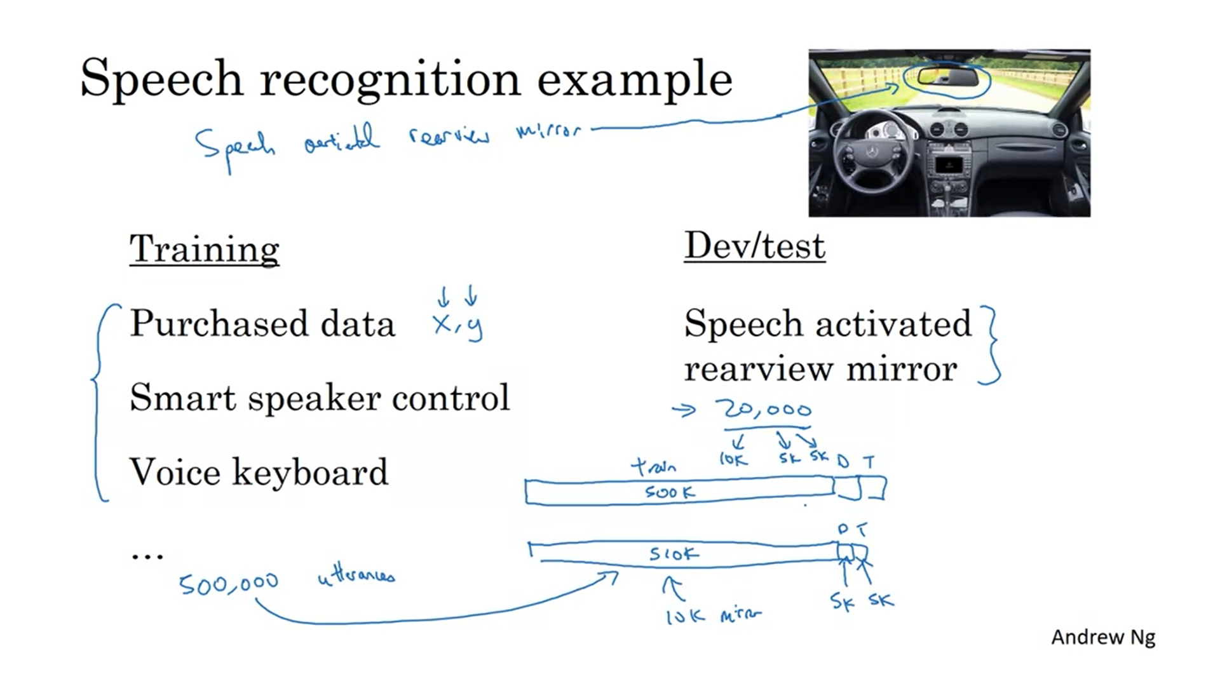

Example: speech activated rearview mirror (this is very common in China).

Maybe you have a lot of data from other speech recognition systems just not from a rearview mirror yet.

The rearview data distribution will be very different (lots of street nagivation queries with car background noise).

By using this extra data you have a much bigger dataset instead of just the 20,000 utterances.

Should you always use all the data you can get? The answer is subtle. It is not always the case.

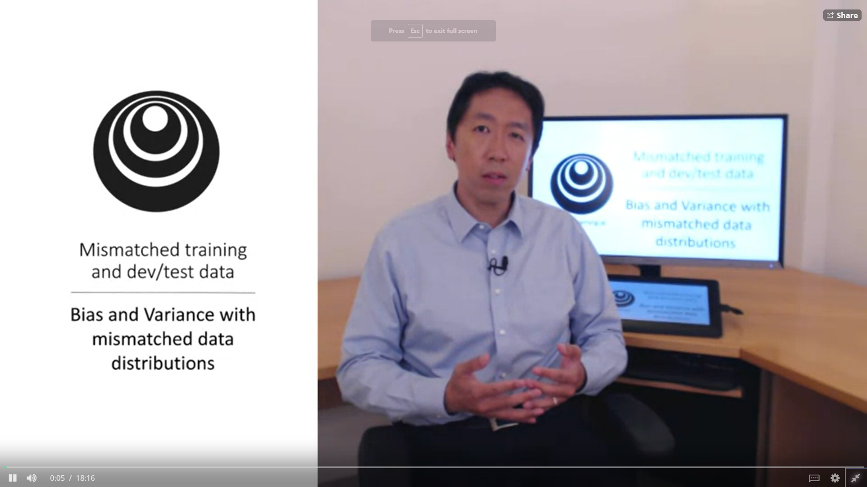

The way you analyse bias and variance changes if your training set comes from a different distribution than dev and test set.

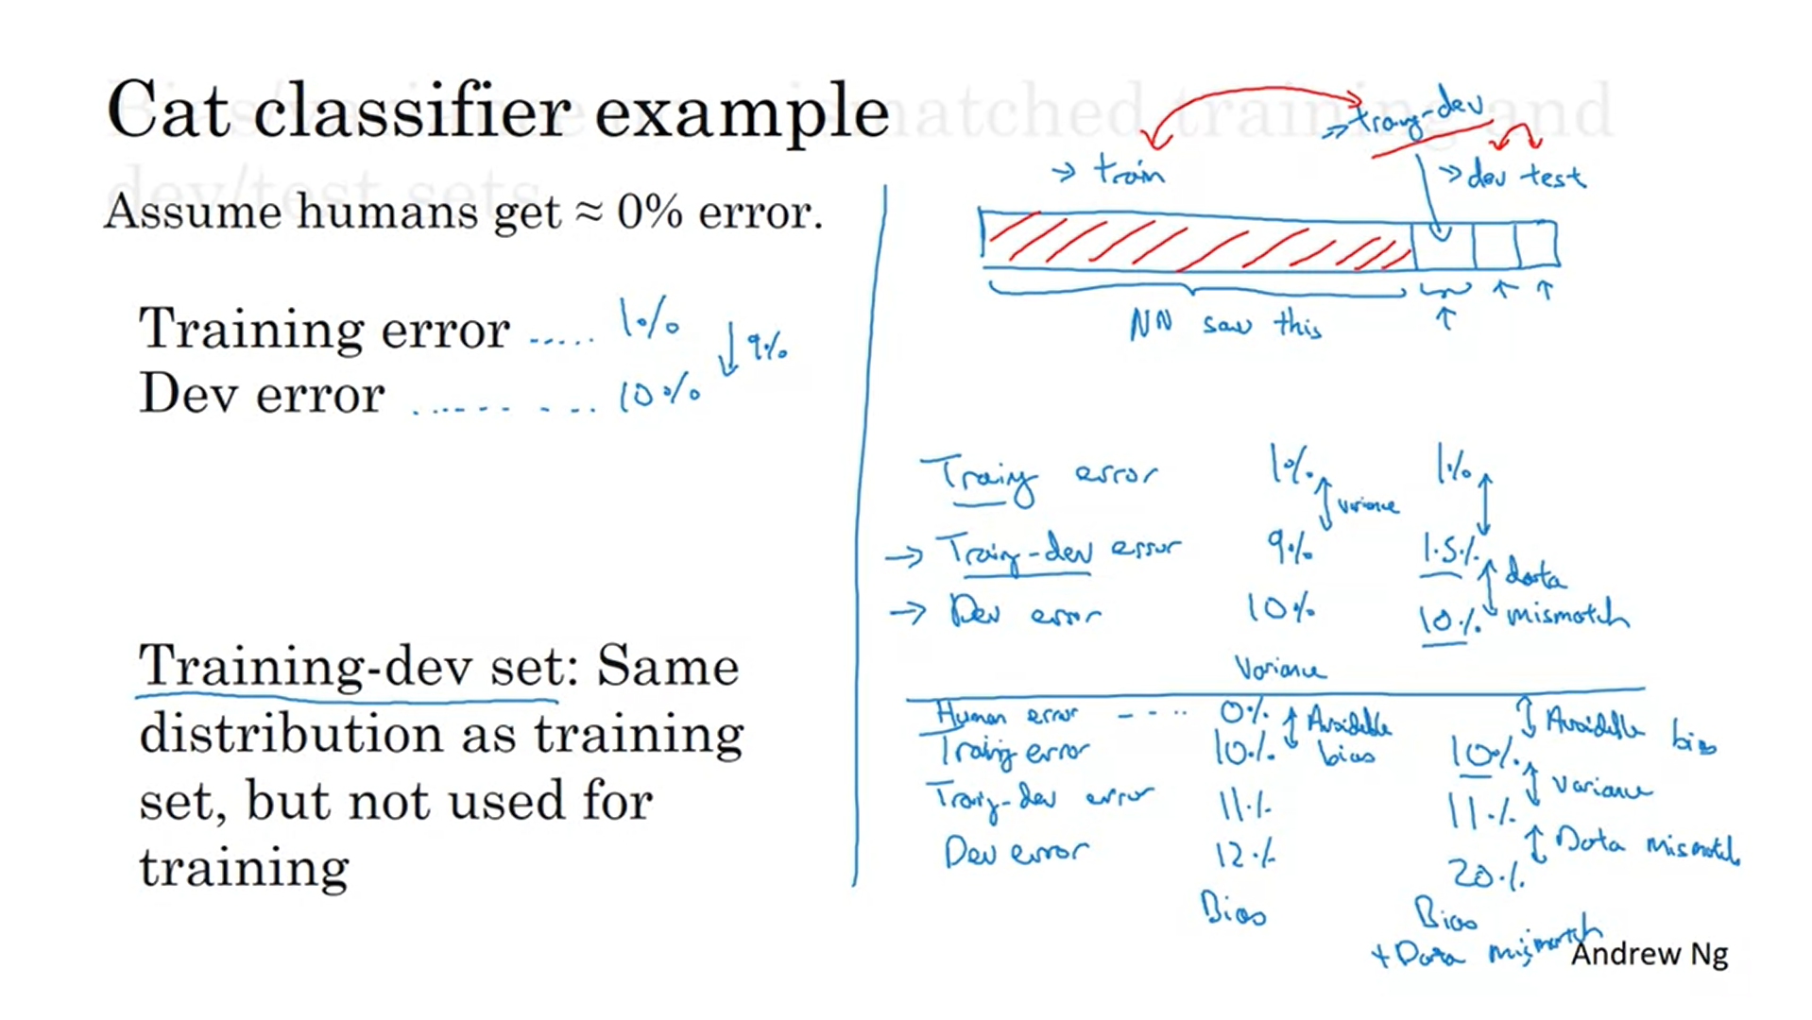

You can no longer safely draw the conclusion that you have a variance problem only because training error and dev error are far apart. Maybe it is doing just fine on the dev set but the training set was just much easier. We do not know which part of the 9% is due to variance and which part is due to different distributions in the data.

In order to tease out these two effects we will define a new subset, the training-dev set (tease out a set of the training set; they will then have the same distribution; but we will not train the network on this piece of data)+.

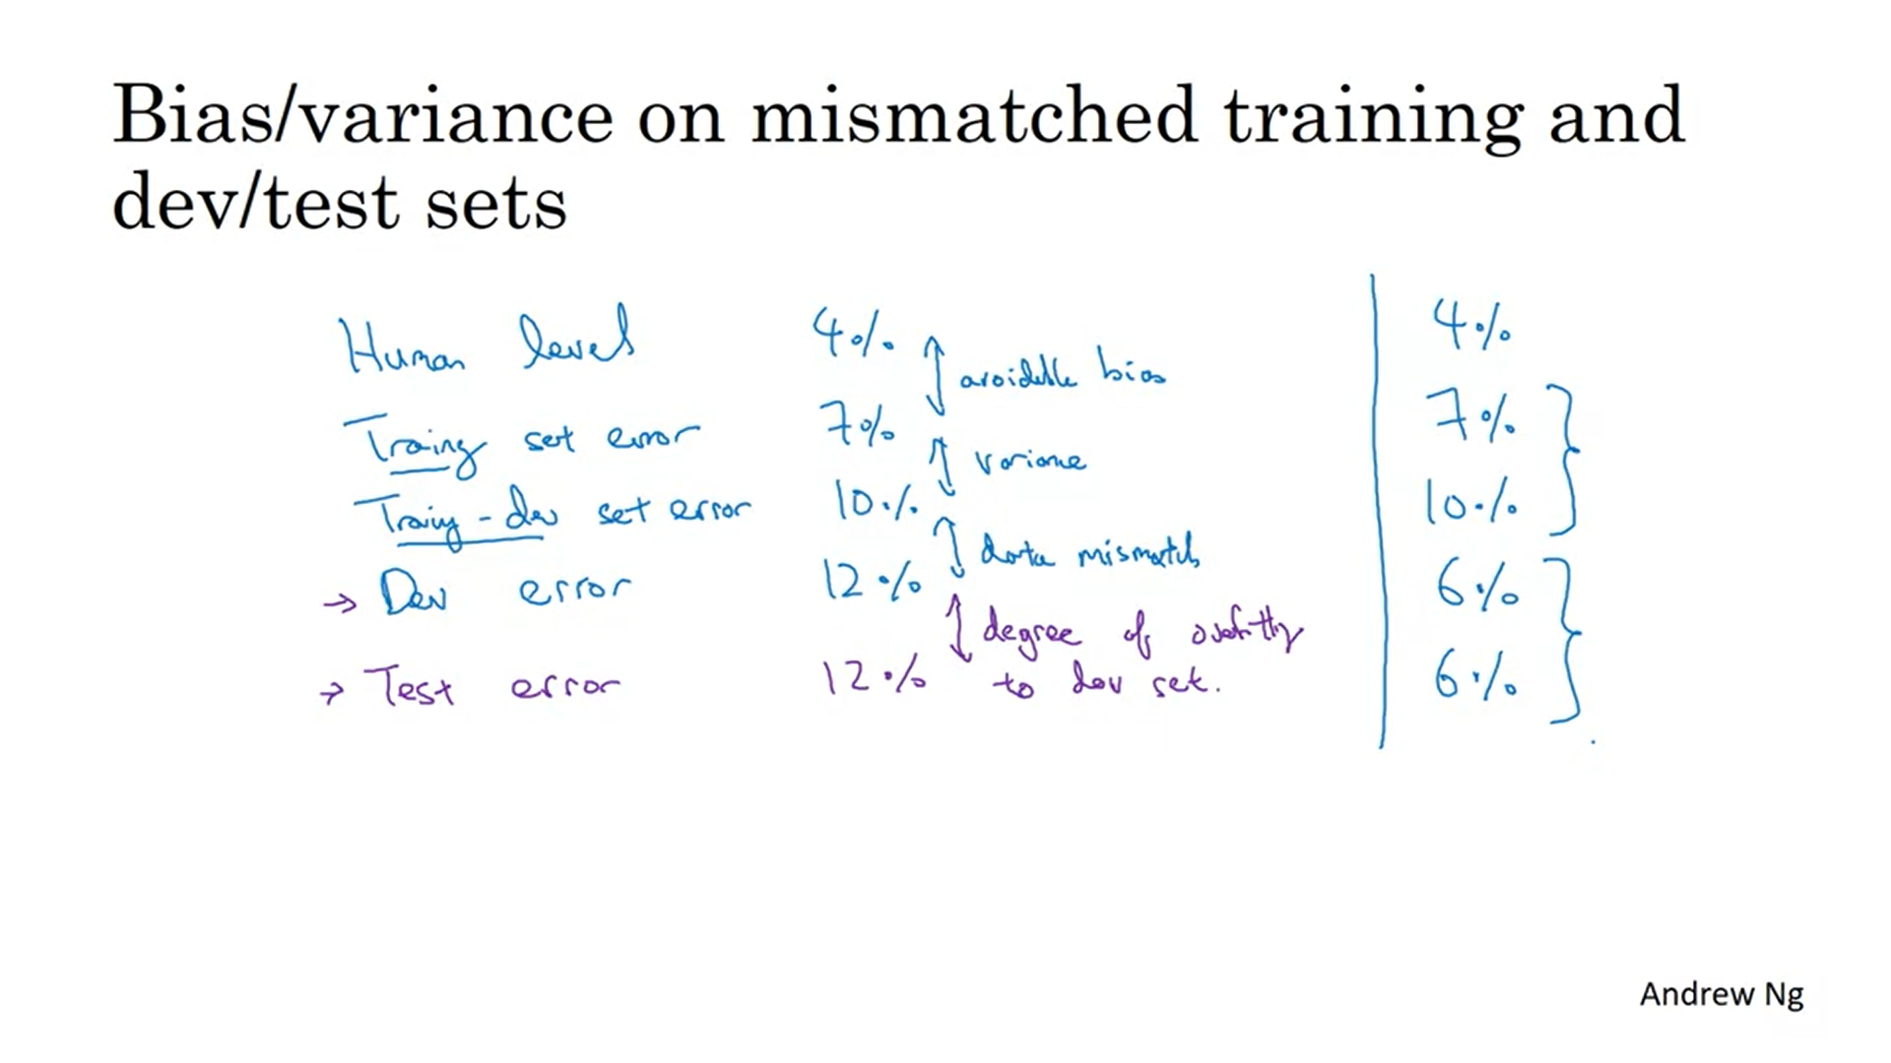

Let’s look at the general principles.

You should not be doing development on your test set.

The numbers do not always have to go up from top to bottom. For example, training set could be much harder than dev/test set.

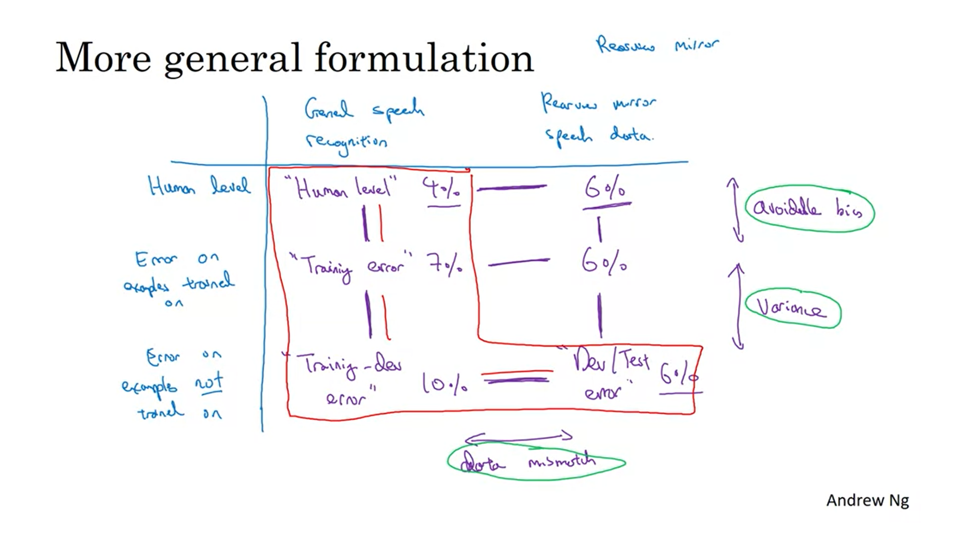

Place the numbers in a table. Example: rearview speech recognition.

X-axis: data distribution.

Marked in red are the previous metrics. It can also make sense to fill in the other 2 values. For example we can get to know that for humans the rearview speech recognition is harder than the general speech recognition.

But how do we address data mismatch? We now have this new problem because the train set follows a different data distribution. What do we do if error analysis detects a lot of errors due to data mismatch?

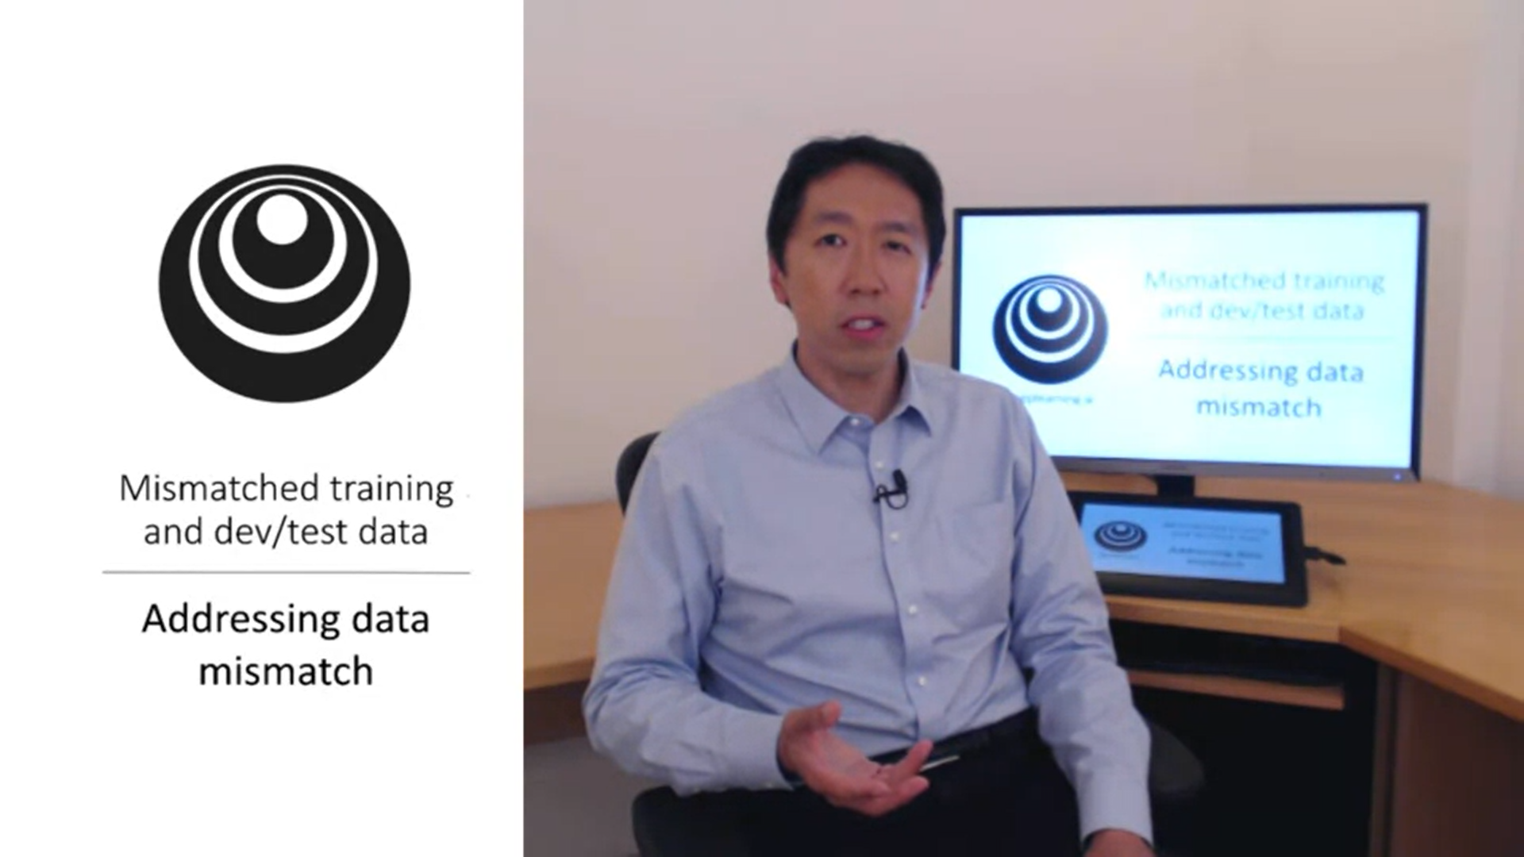

There are not completely systematic solutions to this, just guidelines.

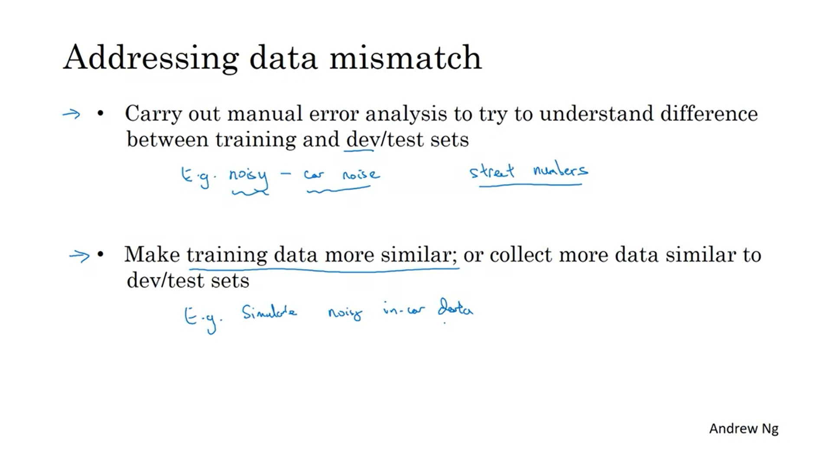

You should only look at the dev set not the test set.

You can use artificial data synthesis to make the data more similar.

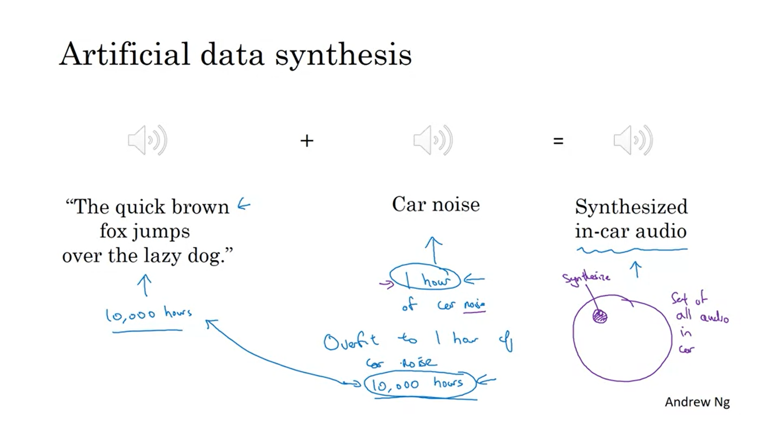

There is one note of caution: if you have 10,000hrs of data that was recorded against a quiet background and only 1hr of car noise, one thing you could do is to use this 1hr to synthesize all 10,000hrs but then there is the danger of overfitting. Even though car noise sounds the same to the human ear, it might not be the case for the dl algorithm.

Using 10,000hrs of unique car noise could perform better.

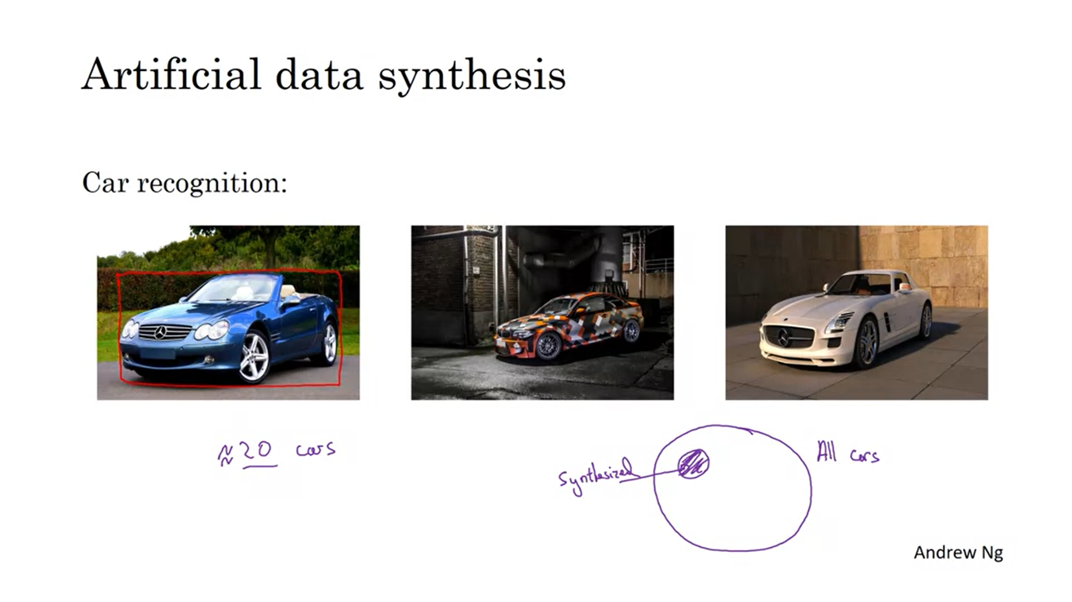Why not use computer graphics to simulate cars for car recognition? Only a small subset of all cars is there as computer graphic. You might overfit to this. It is difficult for a person to tell that there is overfitting because it seems like there are lots of different cars still.

Having said this, artificial data synthesis is very useful and can improve performance a lot but you have to apply caution.